SPIDER_Filippini_mmUniverse2025
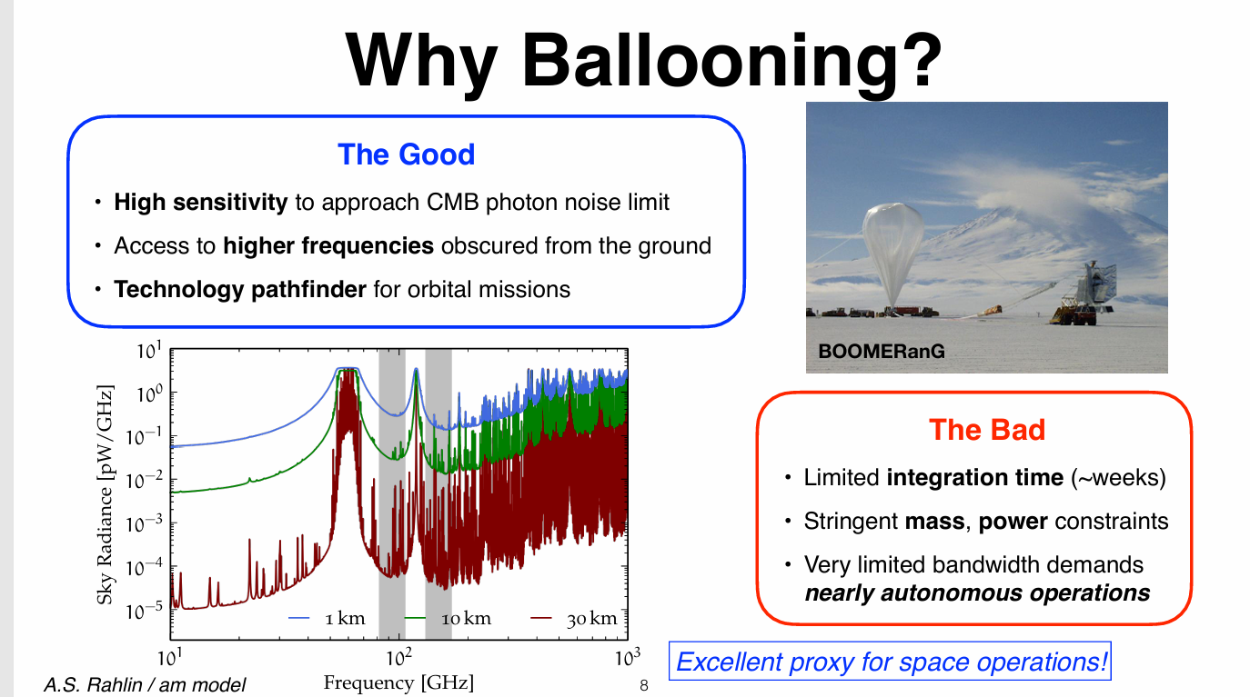

https://indico.uchicago.edu/event/455/contributions/1932/
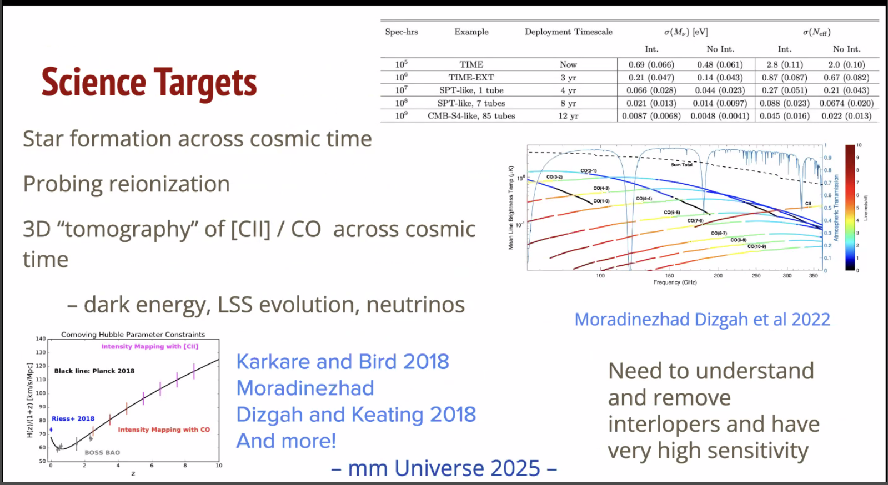

https://indico.uchicago.edu/event/455/contributions/1845/
